 | BAHRIA UNIVERSITY, (Karachi Campus)  Department of Software Engineering  Assignment 4 - Fall 2022

COURSE TITLE: Calculus and Analytical Geometry COURSE CODE: GSC-110
Class: BSE-I (B) Shift: Morning
Course Instructor: Mr. Daniyal ur Rehman Time Allowed: 1 Week
Submission Date: 11-1-2023 Max. Marks: 5 Marks

Question No. 1 [CLO 2: 5 Marks]
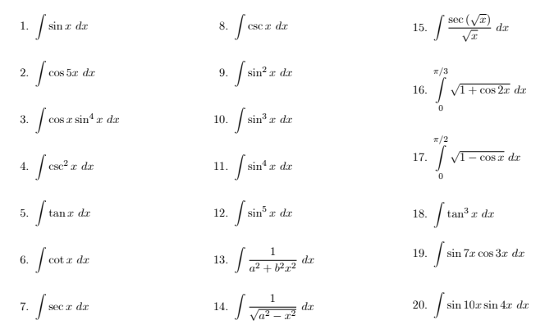
Question No. 2
